- SCOPE:
This document defines roles & responsibilities, requirements, instructions and processes related to the transmission of the MSH Info Templates to Microsoft from each of the first tier vendors.

- SYSTEM REQUIREMENTS:
- Access to Internet
- Microsoft Internet Explorer (IE) 5.0 or above as browser for the Internet
- Windows 98 or above as operating system
- Office 97 or above as the Excel version
- Internet settings: In Microsoft Internet Explorer (IE) in the menu bar, go to tools and internet options and set the “security” to medium-low.

- Prerequisites:
- Prior to logging on to the MSHInfo website you will need to obtain a user name and password from the System Administrator.
- Within Internet Explorer, change your security settings to accept ActiveX enabled pages (See Below).
- Open Internet Explorer
- On the Internet Explorer Toolbar, Click “Tools” and select Internet Options.
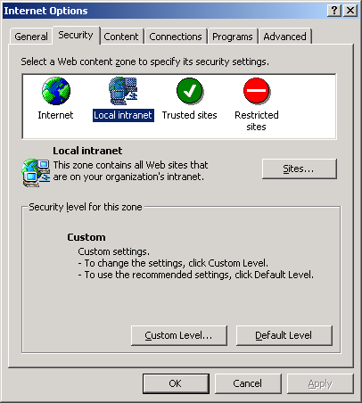
Prerequisites cont.
- In the Internet Options dialog box, choose the “Security” tab at the top.
- Click the “Custom Level” button

- Make sure the 5 separate “ActiveX” radio button options are set to “Enable”.
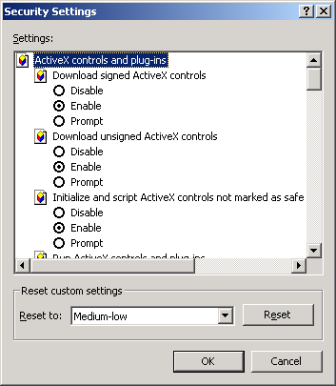
Enable ActiveX Control Options
- After setting “ActiveX” controls to “Enable, click OK
Prerequisites cont.
3. Setup the MSHInfo website as a trusted site.
- Within the Security tab of the Internet Options box, highlight the “Trusted Sites” icon.
- Next, click the “Sites” button below.
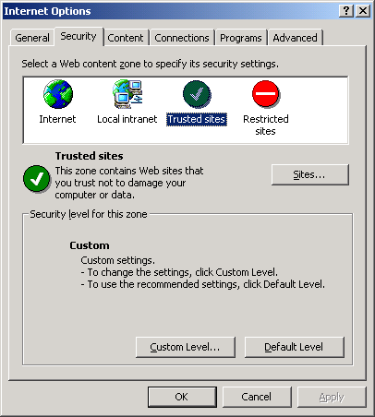

- In the “Add” text box, type: https://mshinfo.one.microsoft.com and click “Add”
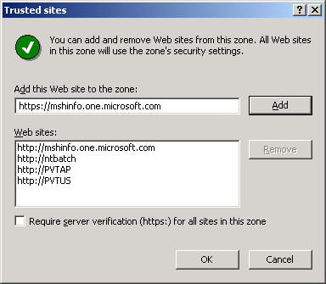
- Click OK and OK once again to return to Internet Explorer.
- Logging On:
- With an internet connection established, start Internet Explorer (version 5.0 or above)

- Type the MSHInfo website address in the address bar:
  - https://mshinfo.one.microsoft.com/
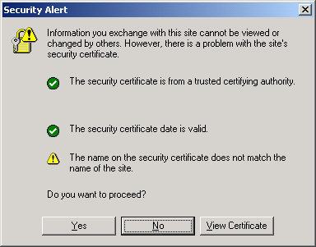
- When the website prompts you, please enter your assigned user name and password, and then click OK.
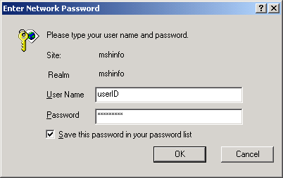
(Microsoft users must enter their domain + “\” then their alias)

- Templates (for Suppliers)
- Once you are in the Homepage, click “Get Template” from the menu at the top of the page.
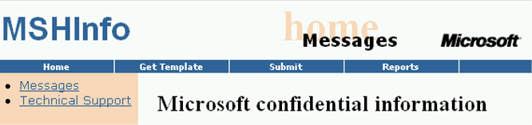

- When you click on the “Get Template, you will see the page shown below.
- Click “3PPForecast” to begin downloading the template.
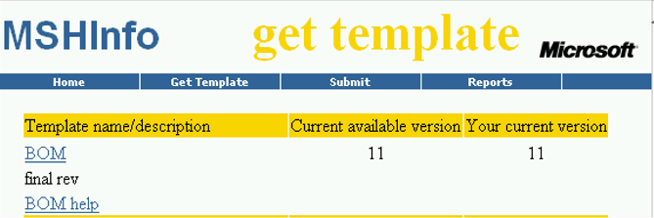
If your Current Version does NOT match your Current Available Version, You MUST DOWNLOAD the most Current Available Version!

- Please “Save as” the document to the hard drive as soon as the excel file opens up so that you can pull the file using the Browse button later on.

  - Submit Template

- On the website click “Submit” in the menu
- Select “3PPForecast” from the first drop-down list (1), then click “Next>>” (2)
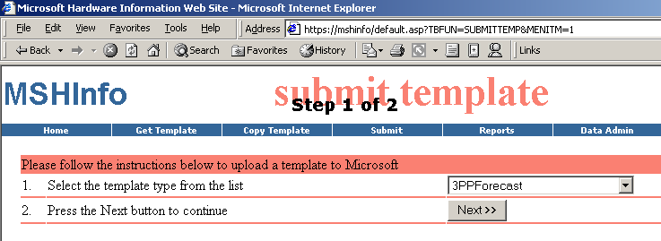

- Click “Browse…” and select the completed file on your hard drive (3), then click “Validate” (4)
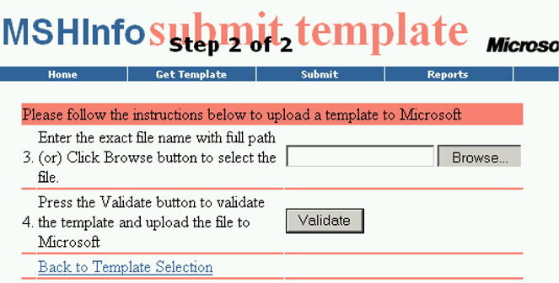

- Wait until the website confirms that the file has been validated and the upload has been completed
- If the file fails validation you will get it back with the incorrect cells in red and the rows in pink
- You will need to rectify the fields, save the document, and then resubmit the file

- REPORTS

  - Reports Section of Website:
- The “Reports” section of the website includes metrics, reports, and tools for various types of information. The CMS reports will have the prefix “CMS” added to them.
- The MSHInfo Admin creates report files offline and posts them to the site using the Data Admin Tool.
- Metrics are assigned to specific users or user groups using the Data Admin tool.
- Metrics files are secure and contain sensitive data.
- Assignment to a specific report file is required before a user can see it listed in the Reports section of the site and download it.

To access the report files click “Reports” in the MSHInfo website menu, then from the list of reports click the one that you want to view.

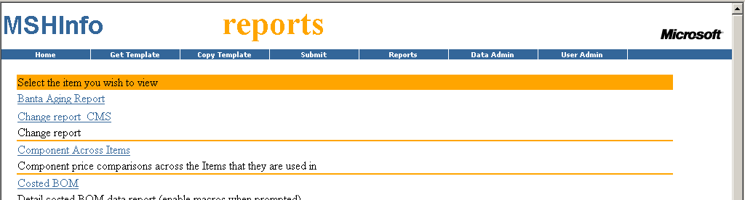

- CONTACTS

  - Primary Contacts
Microsoft Contacts | Email Address
Jake Ledgerwood – Primary Support for MSHInfo | jakeledg@microsoft.com
Chris Aho – Secondary Support for MSHInfo | chrisaho@microsoft.com
Norman Cruz – Business Sponsor for 3PPForecast template | normancr@microsoft.com

